

**Data Foundations Nanodegree Program**

### Project#4 Flight Delays and Cancellations Dashboards

Name: Marwan Saeed Alsharabbi

Date: 23-11-2018

2018

**Introduction**

Delay is one of the most remembered performance indicator of any transportation system

Commercial aviation players understand delay as the period of time by which a flight is late or postponed. Thus, delay may be represented by the difference between scheduled and real times of departure or arrival of a flight

Flight delays have negative impacts, particularly economic, for passengers, airlines and airports

Given the uncertainty of their occurrence, passengers usually plan to travel many hours before their appointments, increasing their trip costs, to ensure their arrival on time. On the other hand, airlines suffer penalties, fines and additional operation costs, such as crew and aircrafts retentions in airports

For this exercise, I took the data that comes from download file excel in class flights.csv, it tracks the on-time performance of US domestic flights operated by large air carriers in 2015

**Project Description**

In this project, you'll create visualizations to reveal insights from a data set. You will create data visualizations that tell a story or highlight patterns in the data set. Your work should be a reflection of the theory and practice of data visualization, such as visual encodings, design principles, and effective communication.

I’m choose from

**Flight Delays and Cancellations**

**Review the column Metadata**

Some of the columns you want to use in your project will have coded values that represent longer more readable values. For instance the cancellation reason column in the flights data set has the values: A, B, C, D These letters are not understandable by thems**elves. You need to replace these letters with the full reason to make your visualizations** including this data more readable.

These letters correspond with the following reasons.

A - Airline/Carrier

B - Weather

C - National Air System

D - Security

**Summary:-**

In this demonstration analysis, analysis of the operation of the airlines

Throughout the United States, where each running area is considered separately and in each separate state

In order to study the various factors of delays inherent in flight operations. The total cancellations each month for 2015 that the design was used during the months only and there are four reasons for the process of cancellation or delay in flights Air

There are four factors for cancellation

A - Airline/Carrier

B - Weather

C - National Air System

D - Security

**Design:-**

When I think of air travel, I immediately began to visualize dramatic geographical locations and change the weather conditions during the year. Choosing and changing airlines for other airlines is not a specific reason for the airline. The national airspace system (NAS) is the United States airspace, facilities and airports along with information, services, rules, regulations, policies, procedures, personnel and associated equipment. Includes common components with the military. Finally, it was the geographical location, the problems of aviation and airlines that drove the visualization process in this project.

The Tableau story of this project is divided into four Designs:-

Design1:- How many cancelled flights are in each Month of the year?

Design2:- What is the highest delay cause based on airline?

Design3:- The map of the United States shows total cancellations of all states

Design4:- show by line chart how many number of flights canceled or diverted or caused by airline delays and arrival times for the month of Year

Design1:- How many cancelled flights are in each Month of the year?

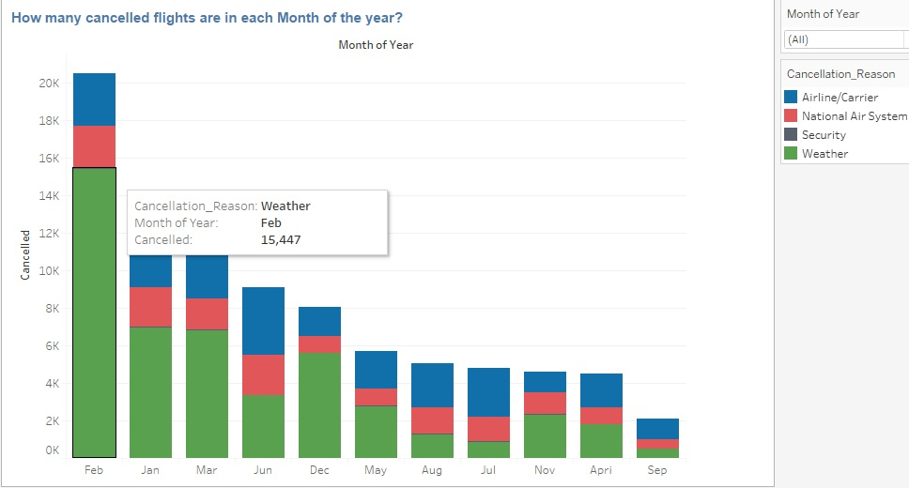In first design focused on the months of cancellation in 2015. The Stacked bar chart was used for visual viewing, making it easy for the viewer to see the total number of cancellations per month with the reason for cancellation. When we point the mouse to the stack column, we define the total. I chose a color gradient green red and blue where green indicates the weather. The most in the redlined column the red indicates national aviation system and blue indicates that the airline / carrier is after the feedback, highlight the most recent cancellations and arrange them from largest to smallest. This lets users know which months the cancellation occurred.

I’m used the stacked bar chart Bar graphs are used to compare objects between different groups or to track changes over time

Both grouped and stacked column charts show a grouped structure in the data they represent, and they both can show a hierarchy one level deep. The differences are what makes them powerful, though. Grouped bar charts are good for comparing between each element in the categories, and comparing elements across categories

**Link Desing1:** <https://public.tableau.com/profile/marwan.saeed#!/vizhome/ProjectFlightDelaysandCancellationsDashboards/Design1>

Design2:**-** What is the highest delay Cause based on airlines?

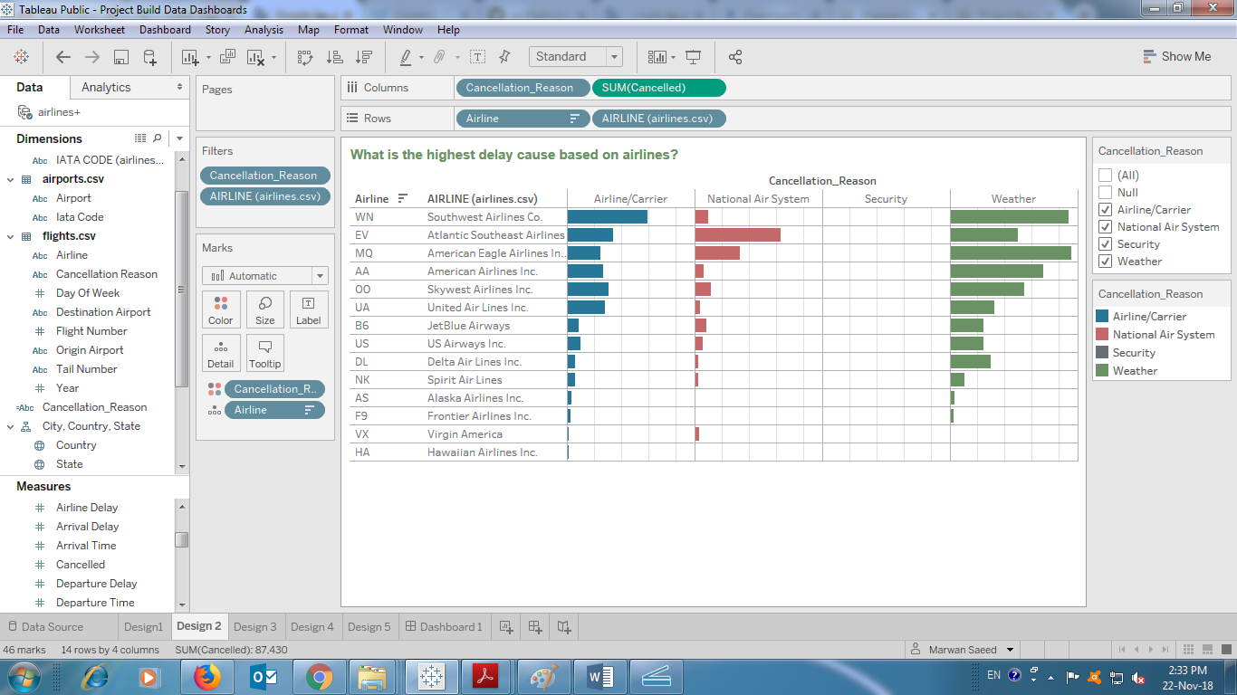In the second design we want to know the reasons for delay for each airline and as shown in the diagram there are four main reasons for canceling flights for each airline through the illustration showing that the Southwest airline co. the largest part of the cancellation because whether [8.758] and Airline/carrier [5,945], National Air System [1.006], Security [12] and in second Atlantic Southeast Airlines, American Eagle Airlines Inc. In the last rank is Hawaiian Airlines Inc. grand total 159

I’m used horizontal chart are one of the many techniques used to present data in a visual form so that the reader may readily recognize patterns or trends. Bar graphs usually present categorical and numeric variables grouped in class intervals. They consist of an axis and a series or labeled horizontal or vertical bars.

**Link Desing2:** <https://public.tableau.com/profile/marwan.saeed#!/vizhome/ProjectFlightDelaysandCancellationsDashboards/Design2>

Design3:**-** The map of the United States shows total cancellations of all states

The third design is a map for each US map and through the tinted colors that show Texas was the second largest American state to come first in total cancellations of flights [13,441] and the second [Illinois](https://en.wikipedia.org/wiki/Illinois) state [11,683]

Cancellations and the third was the state of California in total cancellations of flights of cities [8,023] and Through the check we found the state got the state with the least cancellations in the flights are [Vermont](https://en.wikipedia.org/wiki/Vermont) state [ 65] the blue color shows more states affected by airlines in canceling flights

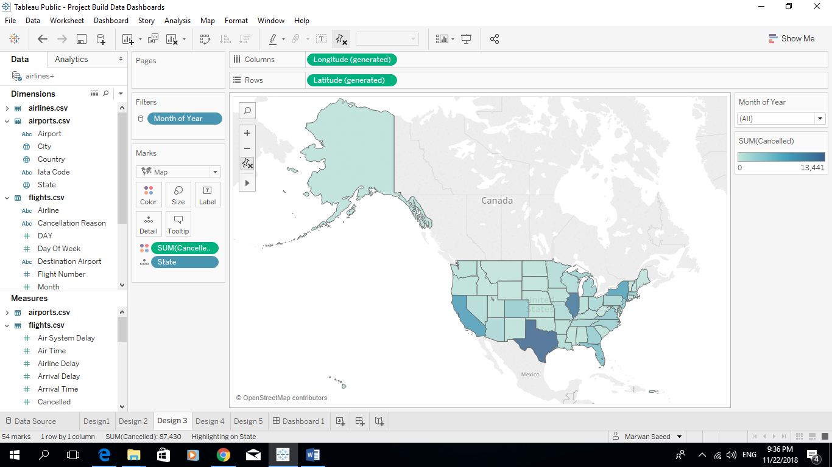

Map charts allow you to position your data in a context, often geographical, using different layers. The layers can be either data layers, such as marker layers or feature layers, or reference layers such as map layers a marker layer, markers or pies are positioned in the different areas a marker is placed in each of the states, and you can interact with the markers just as you do with markers in other visualizations.

**Link Desing3:**

<https://public.tableau.com/profile/marwan.saeed#!/vizhome/ProjectFlightDelaysandCancellationsDashboards/Design3>

Design4:- show by line chart how many number of flights canceled or diverted or caused by airline delays and arrival times for per month for Year

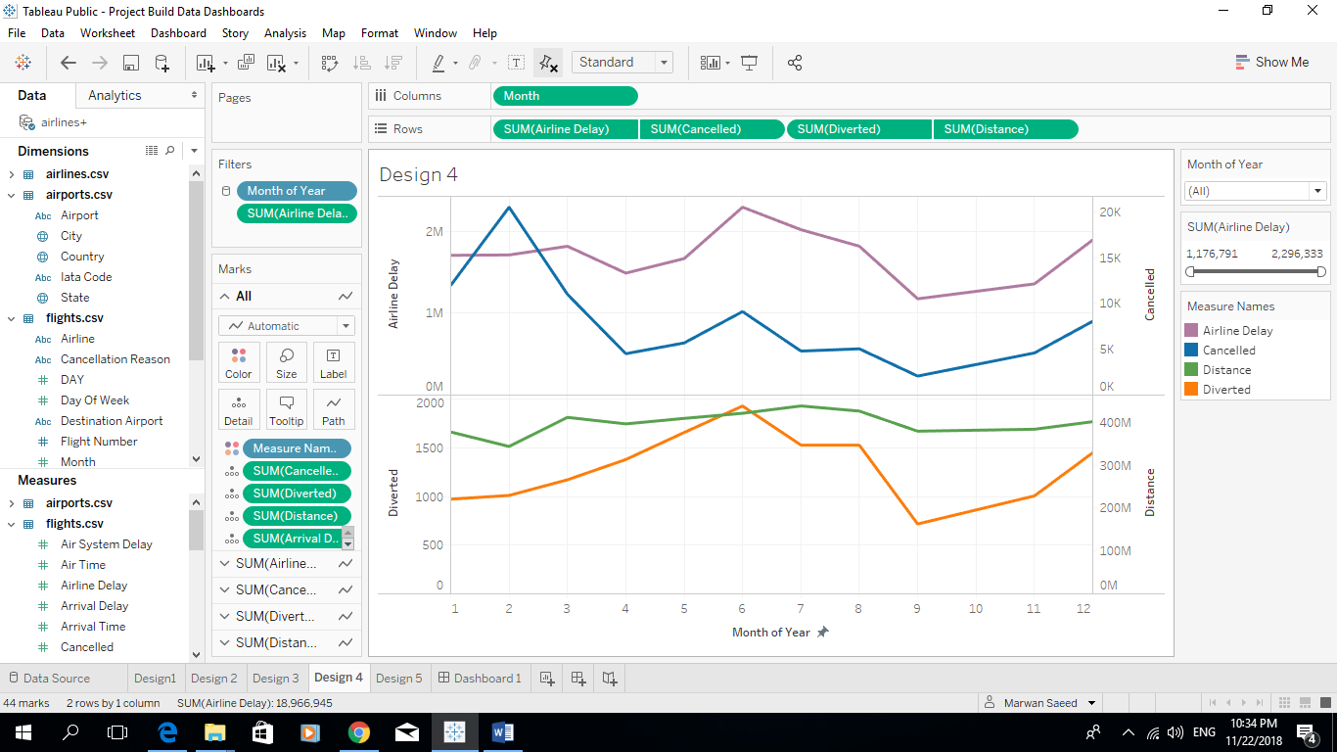In the fourth design by linear chart, the number of canceled cancellations, or due to airline delays and arrival times during each month was reported. The highest cancellation rate was in February with a total of [20,517] and the lowest in the month of September [2.075] The distance was the largest share in July with a total of [438,172,366] and in June indicates the highest flight diverted with a total [1,930] and the lowest diverted in month of Spambeter with a total of [718] See the following picture for details p (1)

I’m Used linear chart to compare changes over the same time period to more than one set continuous data that you would like to represent through a chart then a line chart is a good option. This graph is especially effective.

**Link Desing4:**

<https://public.tableau.com/profile/marwan.saeed#!/vizhome/ProjectFlightDelaysandCancellationsDashboards/Design4>

P (1)

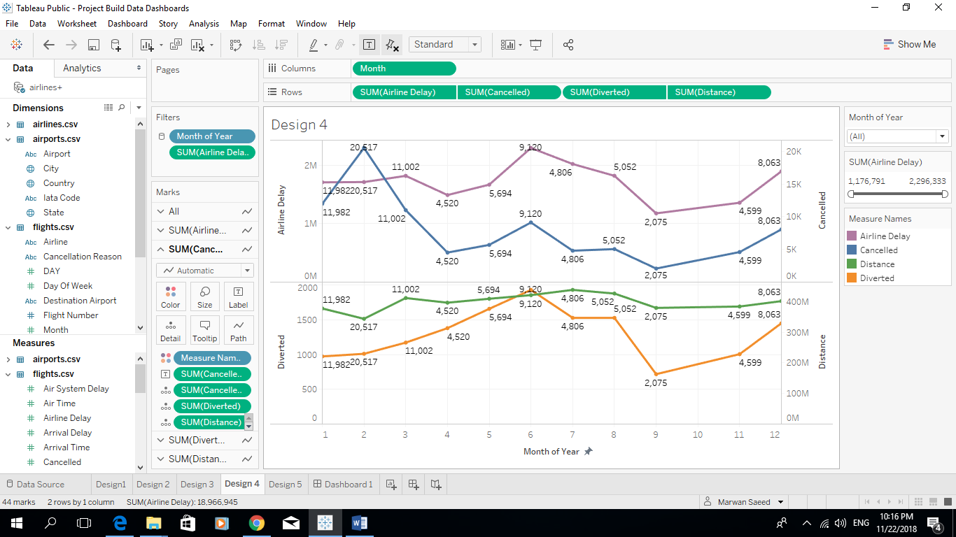

Finally, I have reached the final design of the project that explains the Tableau control panel that analyzes the causes of delays and cancellation of flights in 2015.

The simplicity and objectivity of the viewer is far from complicated

I hope you get a satisfied and happy team at Udacity.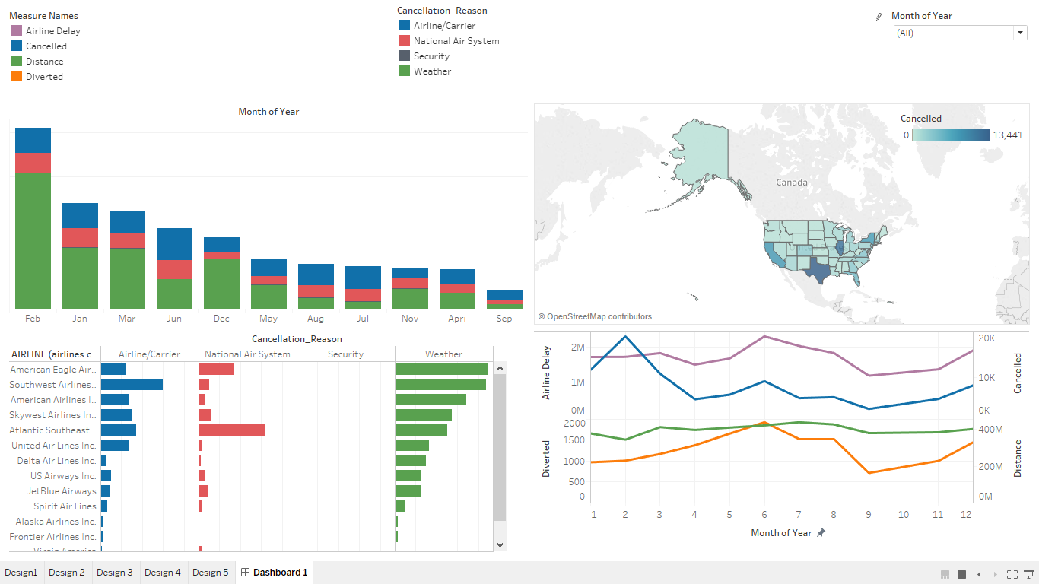

**Link Dashboard1:**

<https://public.tableau.com/profile/marwan.saeed#!/vizhome/ProjectFlightDelaysandCancellationsDashboards/Dashboard1>

Resources

1) Tableau online help

<https://www.tableau.com/support/help>

2) Tableau free training videos

<https://www.tableau.com/learn/training>

3) YouTube

https://www.youtube.com/watch?v=9xqHA732LMA&feature=youtu.be

**I wish success to all.**

M*arwan Saeed* *Alsharabbi*

Thanks Udacity